|  |  |
| --- | --- |
| Name: …………………..….………....……………………………..…..……….…  Address: ………………………………..………………………….…….…………..  ………………………………………………………………………….….…….….…….  Post Code: ……………………………………………….……...……....………..  Tel Home: ………………………………………………………..…………..………  Tel Mobile: ………………………………………………….….………….………..  Email: ……………………………………………………...……..…………………….... | Date of Birth: ………………………………..…… Age ...…..……..  Occupation: …………………………………………..…..…...…..…….  GP Practice: ……………………………………………………….……....  GP Name (if known) ……………………..……….……………........  Do I have permission to contact your GP? Y / N  How did you hear about us? ………..…..….…………………..... |

***Please mark where you are experiencing symptoms / pain***

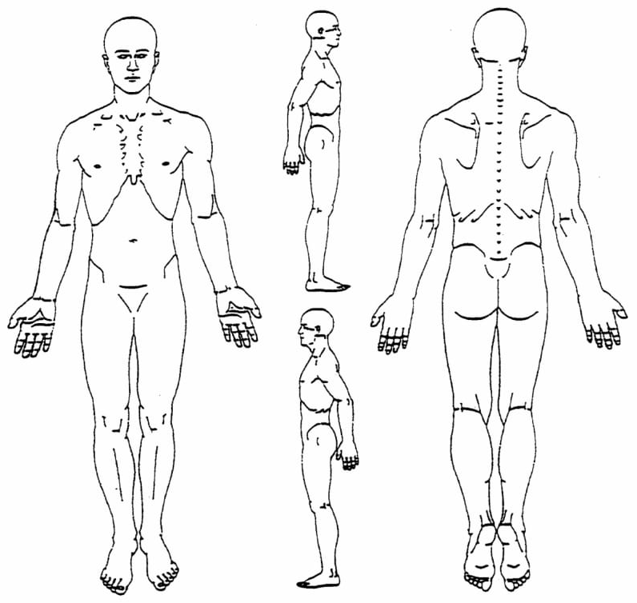Please briefly explain the reason for your visit

What was the cause of the problem?

When did it start?

How would you rate the severity

of the pain at the moment (0=no pain, 10=severe pain)

Please mark all that apply:



Please list All Medications you are taking: …………………………………………………………………………………………..

………………………………………………………..……………………………….…………………………….

(P.T.O.)

Have you had any imaging (X-ray / MRI etc)? ………….…………………………………………………………….…………………………………………..

Have you already had treatment for this problem? …..…………...…………………………………………...……………………………………………

Have you consulted your GP? Yes [ ] No [ ]

Information

Confidentiality: Osteopaths operate under the same confidentiality agreement as doctors and other medical staff, so any information you disclose will be kept in the strictest of confidence and not disclosed to any other third parties unless you give prior permission.

Having any physical therapy treatment whether for preventative care, rehabilitation, or managing a recent acute condition, usually involves some hands on treatment; this often leads to temporary side effects. It’s common to feel a little stiff or sore the next day following the initial treatment; this usually, lasts around 24-48 hours. Most people describe this as similar to ‘post exercise soreness’. It’s also common to feel tired or have a temporary headache after treatment.

Reactions which are extremely rare would include: prolapsed disc, severe pains radiating to a limb, stroke, ‘cauda equina’ syndrome (a condition which can cause bladder and bowel impairment or, nerve damage and muscle weakness)

Make sure you contact your osteopath if you are concerned about any problems you are having.

If you would like to see our Privacy Notice it is available on the website: www.*newhillosteopathy.co.uk*

Please confirm you have read and understood the above Y / N

Cancellation policy – 24hrs notice is required if you wish to cancel your appointment. You are free to cancel your appointment with more than 24hrs notice without any charge. Please confirm you understanding Y / N

We occasionally email about health updates, offers and to let you know about all the fantastic stuff we have going on here at the clinic, your details won’t be shared with anyone outside of this clinic. Is this OK? Y / N

Signed ……………………………….……………………..……… Name ………………………………………………….

Date ………….…………..………………………………………...

_________________________________________________________________________________________________

|  |
| --- |
|  |

Office Use Only

Syst:

# / Op / Hosp / RTA